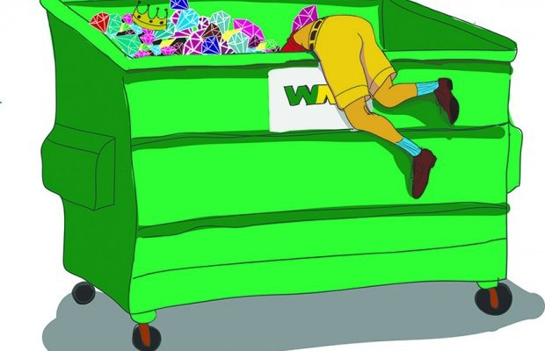
I’m a Dumpster Diver

I was thrilled to be hired as a teacher for preschool children with special needs. As I looked over the files of the children who were going to be placed in my classroom, I knew there would be academic and behavior challenges. What I didn’t expect was the challenge of having to provide most of my own teaching materials. The district managed to provide me with a couple tables and chairs, a few random toys, and access to the teacher supply room that contained construction paper, rolls of bulletin board paper and my best friend, the laminator.

Each child had an IEP containing goals that were to be addressed during the year, but the IEP did not come with any instructions as to how I was supposed to help my little ones achieve those goals. I was told that I could borrow a copy of the curriculum that was being used in the classroom for typically developing four year old kindergarteners. I read through the 4K manual and checked out the suggested activities. Were they kidding? Many of my children were nonverbal or had severe language delays. All of them lacked the basic foundational skills to be successful using this 4K curriculum.

And so, out of frustration, the Read It Once Again curriculum was developed. My children desperately needed language, foundational skills from every domain and lots of repetition. I found that using popular children’s literature was an effective way to meet these needs. The Read It Once Again teaching strategy is based on repeated readings of the story and providing appropriate activities in conjunction with using objects pictured in the illustrations or found in the text.

My favorite fall unit was based on the story “The Little Old Lady Who Was Not Afraid of Anything”. The children loved this story because of the repetitive words and phrases combined with fun gross motor movements. In order to facilitate language development, I needed objects found in the story that they could touch and manipulate. Things like gloves, big heavy work boots, green pants, a woven basket, a black top hat, acorns, an apron, and the list went on and on. Where and how could I get the props needed to help my children learn the language skills that this story offered?

Knowing that there was no money in the district budget for preschool supplies, I did what every teacher does, and that was to pay for needed materials from my own pocket. Buying new objects were not in my personal budget. And so, I began to haunt second hand stores, yard sales, and on occasion even did some dumpster diving. To my surprise, I found that I enjoyed this challenge. Each prop that I found became a valued trophy. With each unit I created a large “prop box” filled with objects that became essential to the success of my students’ ability to acquire language and foundational skills.
Many teachers have asked if Read It Once Again will ever supply kits containing the props to accompany each story. Providing a prop box kit for each unit would drive the curriculum price out of sight for most school districts, not to mention the fact that we know many teachers and therapist buy our units with their own money. We prefer to keep the unit cost reasonable and encourage teachers to acquire their own props.
If dumpster diving is not your idea of a good time, I have another suggestion. Each month before you begin a unit, include a “wish list” of items in your parent newsletter. This serves a double purpose. You’ll be surprised what lurks in their attics, AND most importantly, parents now become involved with the classroom and the curriculum.
Read It Once Again salutes teachers and therapists who serve children with special needs. I know how hard you work and how much time and money you dedicate to the success of your children. We thank you for all you do and for making an incredible difference in the life of a young child.
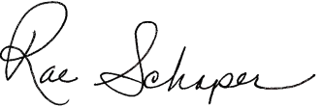
Sincerely,

Author and creator of Read It Once Again

